COUNCIL ASSESSMENT REPORT
HUNTER AND CENTRAL COAST REGIONAL PLANNING PANEL

PANEL REFERENCE & DA NUMBER | PPSHCC-139  DA/1651/2022
PROPOSAL | Residential flat building and commercial premises (mixed use development)
ADDRESS | 114, 116, 118 and 120 Cary Street,  1, 2, 3 and 5 Bath Street  3 Arnott Avenue Toronto
APPLICANT | Fay Vranas
OWNER | Toronto Investments No.1 Pty Ltd
DA LODGEMENT DATE | 9 August 2022
APPLICATION TYPE | Integrated development
REGIONALLY SIGNIFICANT CRITERIA | State Environmental Planning Policy (Planning Systems) 2021 – Schedule 6 Regionally significant development Section 2 General development over $30 million.  The development has a capital investment value of $36,654,768
CIV | $36,654,768
CLAUSE 4.6 REQUESTS | Lake Macquarie Local Environmental Plan 2014 Clause 4.3 Height of Buildings
KEY SEPP/LEP | - State Environmental Planning Policy (Resilience and Hazards) 2021  - State Environmental Planning Policy (Transport and Infrastructure) 2021  - State Environmental Planning Policy (Planning Systems) 2021  - State Environmental Planning Policy (Building Sustainability Index: BASIX) 2004  - Lake Macquarie Local Environmental Plan 2014  Lake Macquarie Development Control Plan 2014
TOTAL & UNIQUE SUBMISSIONS KEY ISSUES IN SUBMISSIONS | Council received a total of 97 submissions
DOCUMENTS SUBMITTED FOR CONSIDERATION | Architectural plans  BASIX assessor certificate  BASIX certificate  Bushfire assessment report alternate solution  Civil engineering plans  Concept stormwater management plan  Disability access report  Economic impact assessment  EPBC Act protected matters report  Geotechnical investigation report  Groundwater drawdown model and detailed settlement  Landscape plans  Noise impact assessment  Operational waste management plan  Peer review of groundwater assessment for proposed development at 118 Cary Street Toronto NSW  Prescribed ecological actions report  Risk assessment guidelines for groundwater dependent ecosystems  SEPP65 Apartment design guide compliance checklist  SEPP65 DA statement – nine design principles  SEPP65 Design verification statement  SEPP65 Sun study  Statement of environmental effects  Statement of heritage impact  Traffic impact assessment  Visual impact assessment
SPECIAL INFRASTRUCTURE CONTRIBUTIONS (S7.24) | N/A
RECOMMENDATION | Refusal
DRAFT CONDITIONS TO APPLICANT | N/A
SCHEDULED MEETING DATE | 6 June 2023
PREPARED BY | Glen Mathews
DATE OF REPORT | 30 May 2023

EXECUTIVE SUMMARY

The development application (DA/1651/2021) seeks consent for construction of two five storey towers as residential flat buildings. The ground floor of the western tower includes a commercial premise with residential accommodation provided above. The eastern tower provides all five levels as residential accommodation. The development is a mixed use proposal comprising residential flat buildings with ground floor commercial space orientated toward the main street frontage (Cary Street).
The subject site consists of nine existing lots known as 114, 116, 118 and 120 Cary Street, 1, 2, 3 and 5 Bath Street and 3 Arnott Avenue Toronto (the site). The site has three frontages including Cary Street to the west, Arnott Avenue to the east and heritage item ‘Fassifern to Toronto Branch Railway line’ to the south. The site is an irregularly shaped area of 5,957m². Main vehicle access to the site is provided along Arnott Avenue with a closed road reserve for Bath Street extending into what is now the site.
With the exception of redundant road reserve and remaining vegetation the site is generally clear of structures with original dwellings have been previously demolished.
The development is located at the edge of the Toronto town centre with an interface to residential zoned land to the north and east. Currently the area comprises a mix of uses with one and two storey detached dwellings, commercial development (McDonalds), Registered Club and Primary school, within vicinty of the proposal.
The site is located in the E1 Local Centre zone pursuant to Clause 2.2 of the Lake Macquarie Local Environmental Plan 2014. Residential flat buildings and commercial premises are both permitted with consent in the E1 zone.
The development site is located within a mine subsidence district and does not meet any deemed to satisfy provision. General terms of approval under Section 22 of the Coal Mine Subsidence Compensation Act 2017 were obtained as integrated development.
The development site is partially bushfire affected with alternate solution provided for the development. General terms of approval under Section 100b of the Rural Fires Act 1997 were obtained as integrated development.
The development will intercept the water table and require dewatering to occur during construction. General terms or approval under section 90 of the Water Management Act 2000 were obtained as integrated development.
Advice was sought from Ausgrid for works in the vicinity of overhead powerlines and Transport for NSW (TfNSW) for traffic-generating development pursuant to the Transport and Infrastructure SEPP.
The proposal was notified from 26 July 2022 until 16 August 2022, a formal extension of one week was provided which extended the notification period until 23 August 2022. Due to issues with document availability the application was renotified from 24 August 2022 until 15 September 2022. A total of 97 submissions, comprising 66 objections and 31 submissions in favour of the proposal were received.
The proposal has a capital investment value (CIV) of $36,654,768. Making the application regionally significant development pursuant to the Planning Systems SEPP. The development satisfies Section 2.19(1), as the proposal meets the criteria in Clause 2 of Schedule 6 as development with value in excess of $30,000,000.00. Accordingly, the Hunter and Central Coast Panel (the Panel) is the consent authority for the application.
A kick-off briefing was held with the Panel on 15 September 2022 where key issues were discussed, including documentation being updated to reflect the current application, noting the Panel will give little weight to previous application. Clause 4.6 requires further justification, urban design principles had not been appropriately met, social impact and crime risk assessments were required for assessment and acoustics, bushfire and groundwater impact on ecology all required further assessment. In addition to these matters there was concern over the level of public interest generated by the application.
A formal request form information (RFI) was issued to the applicant on 23 December 2022 outlining the above matters among other issues identified during the initial assessment.
The applicant lodged a Class 1 appeal with the Land and Environment Court (LEC) on 20 January 2023 with Council receiving formal notification of the appeal on 27 January 2023. A Statement of Facts and Contentions (SOFAC) was filed with the court on 23 February 2023 after consultation with the Panel Chair.
A Panel Briefing was held on 8 March 2023 providing an overview of matters raised through the SOFAC and to seek a pathway forward. The panel resolved to take a position on the application notwithstanding the Class 1 appeal. Council was advised to confirm the applicant’s intention to reply to the RFI. In the absence of any additional information the Panel expected Council to prepare a report for determination based on information currently available.
On 4 April 2023 the applicant advised they would not be providing a response instead choosing to focus on the legal appeal.
Following a detailed assessment of the proposal, in the absence of any additional information, pursuant to Section 4.16(1)(b) of the EPA Act, DA/1651/2022 is recommended for refusal subject to the draft reasons for refusal attached to this report at Attachment A.

- THE SITE AND LOCALITY

  - The Site

The site is irregular in shape (refer to Figure 1) with a frontage of 64m respectively to Cary Street, Victory Parade, Arnott Avenue. The site has a total site area of 5957.5m² with a relatively gentle slope, and is located approximately 4.0m above sea level in a valley between rising landforms to the north and south.
The site is currently vacant with various native and exotic trees and is located on a prominent corner, which is a gateway site into Toronto.
The site is affected by the following constraints:
- Bushfire prone land – part parcel
- Mine subsidence
- Maximum building height of 10m (Victory Parade), 13m (Cary Street) and 16m (Arnott Avenue).
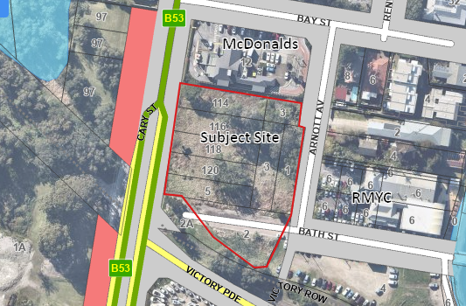
Figure 1 – Site and surrounding context

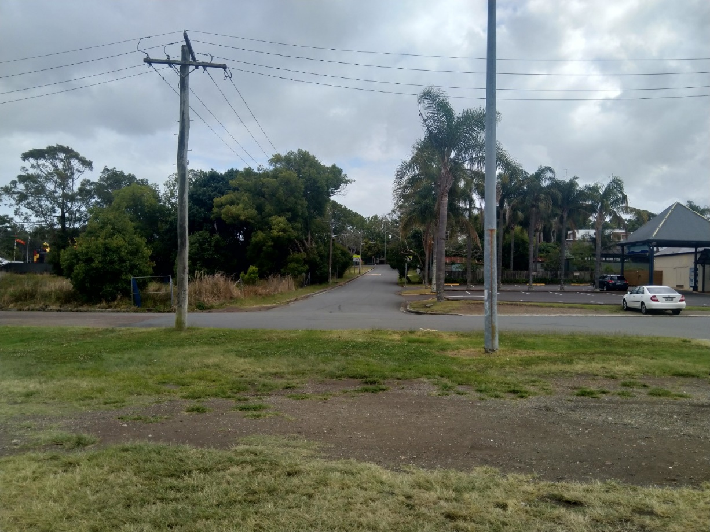
Figure 2 - Looking north toward the site along Arnott Avenue
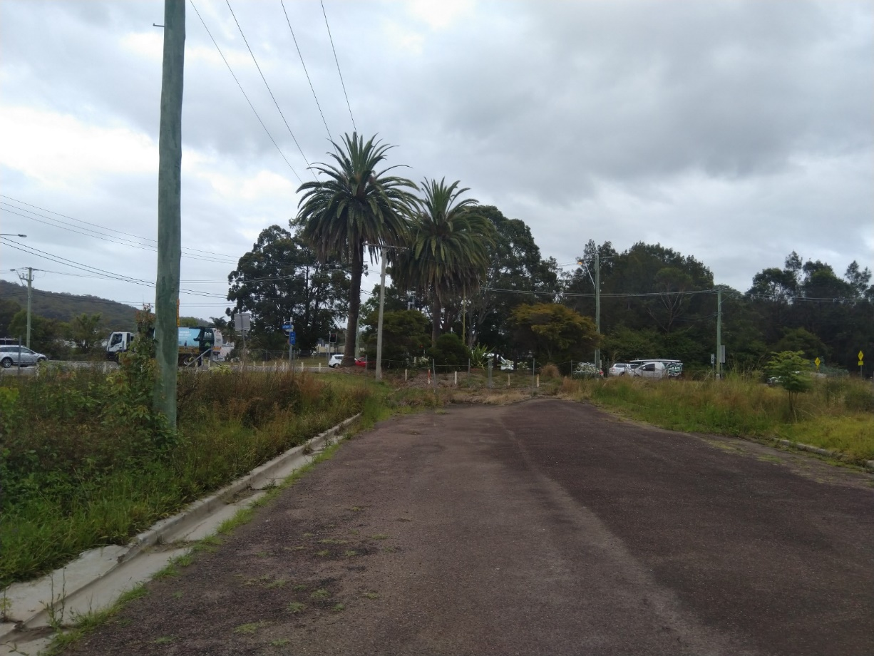
Figure 3 - Redundant road infrastructure for the closed Bath Street road reserve within the site
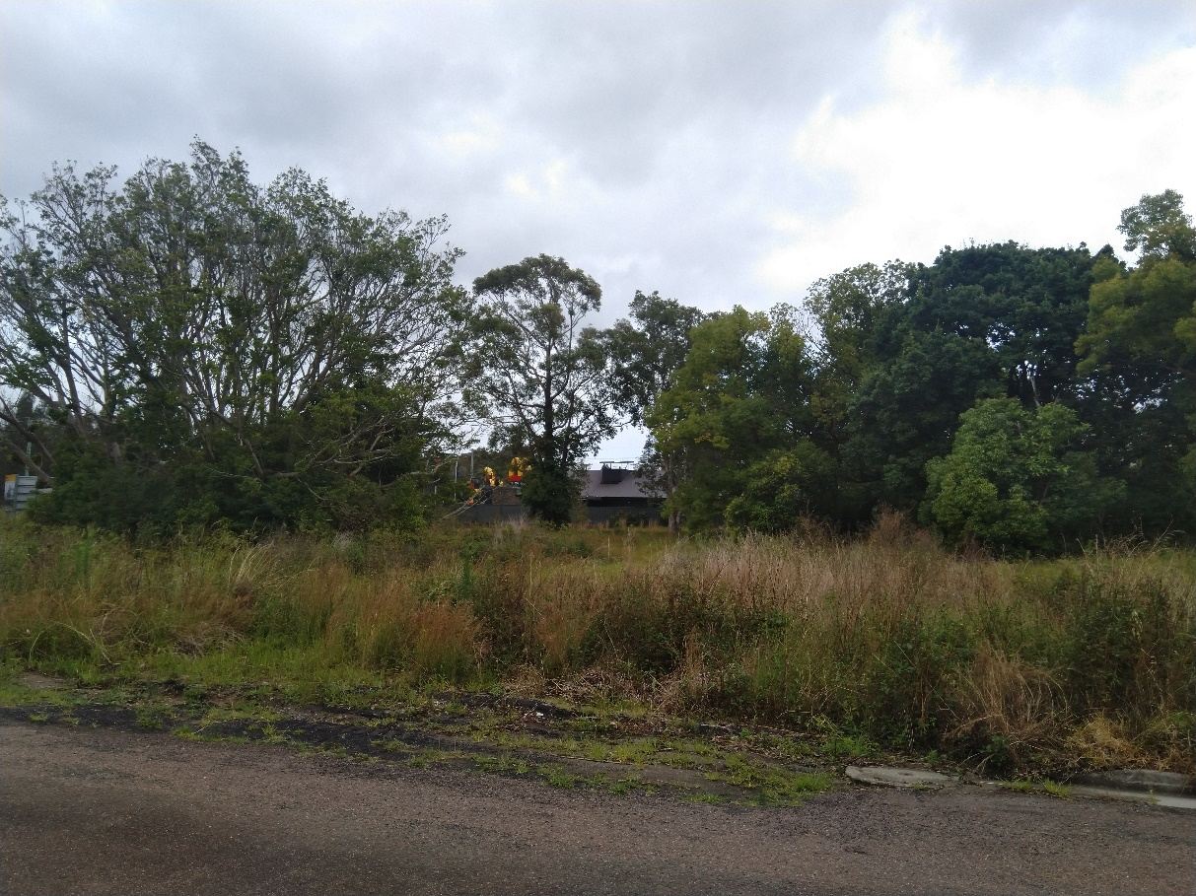
Figure 4 - Current site condition vacant with scattered trees
  - The Locality
The site is located in Toronto on the western side of the Lake Macquarie City Council Local Government Area (LGA) and will include the amalgamation of nine lots.
Immediately adjoining the site to the north is McDonalds at 12 Bay Street, with Toronto Public School located on the northern side of Bay Street.
The site abuts Arnott Avenue to the east, which provides vehicular access to the Royal Motor Yacht Club, a public wharf and residential dwelling houses fronting Lake Macquarie.
To the west the site adjoins Cary Street, which is a busy four lane arterial road. The western side of Cary Street is characterised by undeveloped land, bushland, a coastal wetland and cycleway link to Fassifern.
Adjoining the site to the south are remnants of an old heritage listed railway corridor known as the Fassifern to Toronto Branch Railway Line, and Victory Parade a local road connecting to Toronto Town Centre.
The site is not listed as a heritage item or located within a Heritage Conservation Area. The site is adjacent to the Toronto Heritage Precinct and several heritage items including:
- Heritage item 21 – Fassifern to Toronto Branch Railway Line
- Heritage item 171 – Boatman's Cottage Lakefront; Boathouse and Winches Lakefront; and House;
- Heritage item 172 – Building Restaurant
- Heritage item 173 – Royal Motor Yacht Club Annexe.
The site is located within the Toronto Town Centre Area Plan, which identifies the site as being as being part of the town heritage area.
- THE PROPOSAL AND BACKGROUND

  - The Proposal
The development application proposes a mixed use development (commercial premises and residential flat building) on the site (refer to Figures 5-8 below) including:
Excavation to accommodate two levels of basement car parking (208 car spaces in total) with vehicular access from Arnott Avenue. The basement occupies most of the site with the lowest basement at RL-1.5 metres requiring excavation to depths ranging from approximately 5m – 7m from the existing ground level. The basement levels include:
Basement level 1
- 46 mixed commercial and residential parking spaces including 4 accessible spaces
- 54 resident only parking spaces
- 4 motorcycle spaces
- Bicycle storage
- Carwash bay
- Storage areas for units
- Cleaner and staff facilities
- Service cupboards
Basement level 2
- 108 residents only parking spaces including 12 accessible spaces
- 8 Motorcycle spaces
- Storage areas for units
Commercial premise is proposed at ground floor level (identified as Level 1) of the western tower (Cary Street Frontage) as a single tenancy with 928m² floor area.
A commercial loading dock, and separate commercial / residential garbage storage at ground floor level with ingress from Arnott Avenue and egress onto Cary Street for service vehicles only.
Residential flat buildings propose 108 units including:
- 18x 1 bedroom apartments
- 66 x 2 bedroom apartments
- 24 x 3 bedroom apartments
The massing break up is achieved with two main building forms (Cary Street Block and Arnott Avenue Block) separated by a large landscape area and communal access ways at ground level.
Cary Street Block
- The building fronting Cary Street is six storeys in height (this includes the rooftop terrace).
- Ground level consists of commercial premises and lobby access for upper level residential.
- Residential development fronting Cary Street (Levels 2-5) with total of 43 units.
- Level 6 provides for the communal rooftop terrace.
Arnott Avenue Block
- The building fronting Arnott Avenue is six storeys in height (this includes the rooftop terrace).
- Residential development fronting Arnott Avenue (Levels 1-5) with a total of 65 units.
- Level 6 provides for the communal rooftop terrace.
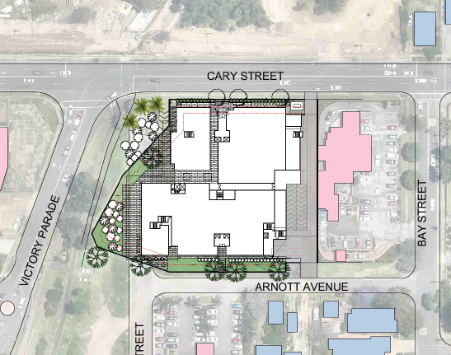
Figure 5 - Proposed site plan

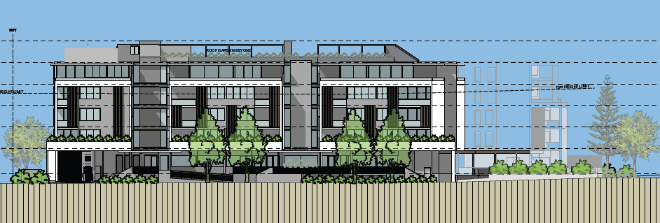
Figure 6 - Proposed western elevation (Cary Street)
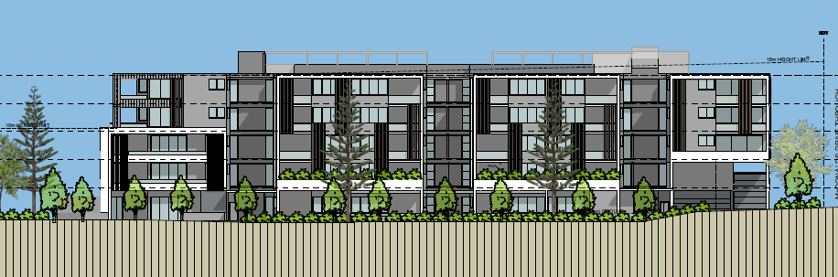
Figure 7 - Proposed eastern elevation (Arnott Avenue)
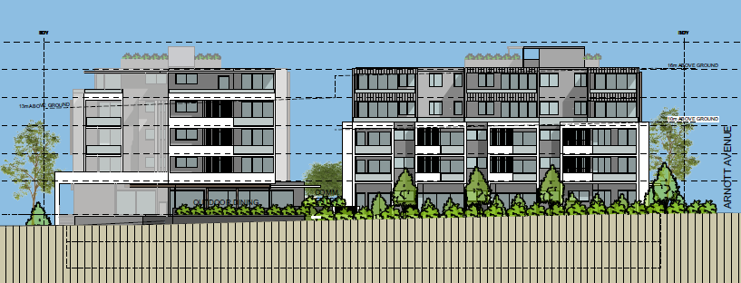
Figure 8 - Proposed southern elevation
Table 1: Development Data
Control | Proposal
Site area | 5957.5m²
GFA | 928m² commercial GFA  10424m² residential GFA  Total GFA – 11,352m²
FSR (retail/residential) | N/A
Clause 4.6 Requests | Yes – Clause 4.3 Height of Buildings
No of apartments | 108 units
Max Height | 20.34m
Landscaped area | 1147m² or 19% of the site
Car Parking spaces | 208 Parking spaces
Setbacks | Minimum northern setback 6m  Minimum eastern setback 4m  Minimum southern setback 3m  Minimum western setback 3m

  - Background
The development site has a long history with numerous pre-lodgements, development applications and appeals having been considered.
The development application was formally lodged on 9 August 2022. A chronology of the development application since lodgement is outlined below, including the Panel’s involvement with the application:
Table 2: Chronology of the DA
Date | Event
9 August 2022 | DA lodged
11 August 2022 | DA referred to external agencies
26 July 2022 – 14 September 2022 | Exhibition of the application
15 September 2022 | Kick-off briefing with Panel
23 December 2022 | Request for information issued to the applicant
27 January 2023 | Council received formal notice of Class 1 appeal
2 February | Council formally notified the HCCRPP of the Class 1 appeal
23 February 2023 | Statement of Facts and Contentions lodged with the court
8 March 2023 | Assessment update briefing with Panel
4 April 2023 | Applicant advised they would not be providing a response to Council’s request for information
30 May 2023 | Assessment report and recommendation submitted to Panel

  - Site History
DA/1495/2005
Council approved a mixed use development on the site on 23 April 2007 including:
- Demolition of existing dwelling houses and structures;
- Construction of a mixed use development comprising retail and commercial tenancies at ground floor level with mezzanine and a five storey residential flat building with 44 apartments
- Excavation to accommodate basement car parking with 113 spaces
- Public domain improvements
- Landscaping
- Subdivision.
DA/1495/2005/A
Under the former provisions of Section 96(2) of the Environmental Planning and Assessment Act 1979, the following modifications were approved by Council on 19 August 2008:
- Residential: increase in apartments from 45 to 55 with an increase in height, reconfiguration of layouts, balconies and lobby areas
- Commercial: deletion of walkway and mezzanine level, addition of commercial floor space on level 1
- Car park: reconfiguration and increase in car parking from 113 to 142 spaces and changes in levels
- Landscaping: relocation of oak tree
- Communal open space: deletion of approved communal open space with new swimming pool, change rooms and outdoor area on commercial rooftop
- Materials and finishes: changes to balustrade treatments and location of selected materials.
PL/97/2016
A pre-lodgement meeting was held with Council on 12 July 2016 to discuss a mixed use development on the site. In summary and in accordance with the controls contained within Part 4 (Development in Business Zones), Section 2.22 (Sites where a concept plan is required) of Development Control Plan (DCP) 2014, Council advised on preparation of an urban design analysis for review by Council’s Design Review Panel (DRP).
SEPP65/20/2016
A concept meeting with the DRP was held on 8 February 2017.
SEPP65/20/2016/A
A further concept meeting with the DRP was held on 10 May 2017.
DA/419/2018
Was lodged with Council on 15 March 2018 for a mixed use development (commercial premises and residential flat building) on the site consisting of:
- Excavation to accommodate two levels of basement car parking (268 car spaces in total) with vehicular access from Arnott Avenue
- Commercial premises at ground floor level with two tenancies (1210m²) fronting Cary Street and two tenancies (1641m²) fronting Arnott Avenue and Victory Parade / the reserve
- A commercial loading dock, three service delivery car spaces and separate commercial / residential garbage storage at ground floor level with ingress from Arnott Avenue and egress onto Cary Street for service vehicles only
- Residential flat building with 124 apartments in total including:
  - 25 x 1 bedroom
  - 78 x 2 bedrooms
  - 21 x 3 bedrooms
- Two main building forms (Cary Street Block and Arnott Avenue / Victory Parade Block) separated by a large communal landscaped outdoor space at podium level on Level 2.
SEPP65/20/2016/B
The development application was considered by the DRP on 13 June 2018.
Determination of DA/419/2018
The development application was determined by way of refusal by the Hunter and Central Coast Regional Planning Panel (RPP) on 11 December 2019 for the following reasons:
- The proposed height and visual impact of the building along Cary Street is inappropriate and is contrary to the allowed building height under Lake Macquarie Local Environmental Plan 2014 and local planning objectives for the area.
- The submitted clause 4.6 Exception to development standards request for building height is not well founded, does not demonstrate sufficient environmental planning grounds to justify contravening the standard and does not demonstrate that compliance with the standard is unreasonable or unnecessary in the circumstances of the case.
- The proposal has not considered and addressed the potential environmental effects on the adjacent SEPP 14 wetland (Wetland 863), nor has it demonstrated compliance with the relevant requirements and considerations under SEPP 14. In addition, Council’s Ecologist indicated significant uncertainty regarding the Applicant’s Environmental Management Plan.
- The proposal provides inadequate setbacks to the northern side boundary, which are inconsistent with the SEPP 65 Apartment Design Guide, and result in inadequate building separation to the adjoining property, including separation from the existing use of that property and any future redevelopment of the land. Additionally, the inadequacy of the northern side setback is exacerbated by the non-complying building height along part of this elevation and the limited articulation of the side elevation, particularly as viewed from Cary Street.
- The proposal has not adequately addressed acoustic and odour impacts from the adjoining McDonalds restaurant, including the drive-thru service area adjacent to the subject land. Relevant considerations include impacts on future residents and impacts on the approved restaurant use operations.
- The proposal is inconsistent with the objectives and requirements of the Toronto Town Centre Area Plan/ Lake Macquarie Development Control Plan (DCP) 2014.
- The proposal has not adequately addressed the traffic impacts of the development on surrounding streets, and having regard to other uses in the area (including the Yacht Club, Toronto Public School, McDonalds, other residential uses), and has not provided additional information as requested by Roads and Maritime Services (RMS). The applicant has not demonstrated that the RMS is satisfied with the proposal.
- The proposal does not adequately address the narrow width of Arnott Avenue adjoining the site, the implications of this for the safe movement of vehicles and pedestrians, and requirements for road widening.
- The proposal does not meet the visitor parking requirements of Lake Macquarie DCP 2014, including the use of shared spaces, which is likely to impact on car parking in surrounding streets.
- The proposal has not resolved issues raised by Hunter Water, including relocation of the pipeline easement, and the Stormwater Management Plan involving Council’s operational land at 2A Bath Street has not been resolved with Council.
- Approval of this proposal in its current form would not be in the public interest.

Land and Environment Court appeal to determination of DA/419/2018
A Class 1 appeal was lodged with the Land and Environment Court in March 2020. Concerns were not resolved through section 34 conferencing, and as such the appeal proceeded to trial.
Proceedings were discontinued by the applicant in September 2021.
DA/1651/2022
The development application was lodged with Council on 9 August 2022.
- STATUTORY CONSIDERATIONS

When determining a development application, the consent authority must take into consideration the matters outlined in Section 4.15(1) of the Environmental Planning and Assessment Act 1979 (‘EPA Act’). These matters as are of relevance to the development application include the following:

- the provisions of any environmental planning instrument, proposed instrument, development control plan, planning agreement and the regulations
(i) any environmental planning instrument, and
(ii) any proposed instrument that is or has been the subject of public consultation under this Act and that has been notified to the consent authority (unless the Planning Secretary has notified the consent authority that the making of the proposed instrument has been deferred indefinitely or has not been approved), and
(iii) any development control plan, and
(iiia) any planning agreement that has been entered into under section 7.4, or any draft planning agreement that a developer has offered to enter into under section 7.4, and
(iv) the regulations (to the extent that they prescribe matters for the purposes of this paragraph),
that apply to the land to which the development application relates,
- the likely impacts of that development, including environmental impacts on both the natural and built environments, and social and economic impacts in the locality,
- the suitability of the site for the development,
- any submissions made in accordance with this Act or the regulations,
- the public interest.

These matters are further considered below.
It is noted that the proposal is considered to be (which are considered further in this report):
- Integrated Development (s4.46)
Coal Mine Subsidence Compensation Act 2017
Section 22: Approvals for development within mine subsidence districts
The site is identified as being within a mine subsidence district. In accordance with Section 22, an application for approval to alter or erect improvements, or to subdivide land, within a mine subsidence district is to be made in a form approved by the Chief Executive.
The application was submitted to Subsidence Advisory as integrated development. General Terms of Approval (GTAs) were issued by Subsidence Advisory NSW, dated 5 September 2022 (Ref: TBA22-03189). It is considered the application has satisfied requirements of the Coal Mine Subsidence Compensation Act 2017.
Rural Fires Act 1997
Section 100B: Bush fire safety Authority
The site is mapped as containing bushfire prone land. In accordance with Section 100B, A bushfire Safety Authority was sought for the development.
The application was submitted to NSW Rural Fire Service (NSW RFS) as integrated development. A Bushfire Safety Authority was issued with GTAs by NSW RFS, dated 29 November 2022 (Ref: DA20220822010125). It is considered the application has satisfied requirements of the Rural Fires Act 1997.
Water Management Act 2000
Section 90: Water management work approval
The works identified are anticipated to disrupt groundwater, which requires a Water supply work approval for dewatering during the construction phase and ongoing extraction will require a Water Access Licence.
The development was referred to Water NSW as integrated development under the provisions of Section 90. Water NSW issued GTAs, dated 6 October 2022 (Ref: IDAS1145580). The correspondence provided with GTAs specifies the GTA’s do not constitute an approval under the Water Management Act, and set out the requirements for applying for a Water Supply Work approval prior to commencement of works. It is considered the application has satisfied requirements of the Water Management Act 2000, subject to inclusion of GTAs.
  - Environmental Planning Instruments, proposed instrument, development control plan, planning agreement and the regulations

The relevant environmental planning instruments, proposed instruments, development control plans, planning agreements and the matters for consideration under the Regulation are considered below.
- Section 4.15(1)(a)(i) - Provisions of Environmental Planning Instruments

The following Environmental Planning Instruments are relevant to this application
- State Environmental Planning Policy (Biodiversity and Conservation) 2021
- State Environmental Planning Policy (Building Sustainability Index: BASIX) 2004
- State Environmental Planning Policy No 65—Design Quality of Residential Apartment Development
- State Environmental Planning Policy (Planning Systems) 2021
- State Environmental Planning Policy (Resilience and Hazards) 2021
- State Environmental Planning Policy (Transport and Infrastructure) 2021
A summary of the key matters for consideration arising from these State Environmental Planning Policies are outlined in Table 3 and considered in more detail below.
Table 3: Summary of Applicable Environmental Planning Instruments

EPI | Matters for Consideration | Comply (Y/N)
BASIX SEPP | No compliance issues identified subject to imposition of conditions. | Y
SEPP 65 | - Clause 30(2) - Design Quality Principles - The proposal is contrary to the design quality principles and the proposal is contrary to the ADG requirements for separation. | N
State Environmental Planning Policy (Planning Systems) 2021 | Chapter 2: State and Regional Development  - Section 2.19(1) declares the proposal regionally significant development pursuant to Clause 2 of Schedule 6 as it comprises general development in excess of $30 million. | Y
SEPP (Resilience & Hazards) | Chapter 2: Coastal Management  - Section 2.8(1) - Development on land in proximity to coastal wetlands or littoral rainforest  - Section 2.10(1) & (2) - Development on land within the coastal environment area  - Section 2.11(1) - Development on land within the coastal use area  - Section 2.12 - Development in coastal zone generally —development not to increase risk of coastal hazards.  - Section 2.13 - Development in coastal zone generally - coastal management programs to be considered.  Chapter 4: Remediation of Land  - Section 4.6 - Contamination and remediation has been considered in the Contamination Report and the proposal is satisfactory subject to conditions. | N
State Environmental Planning Policy (Transport and Infrastructure) 2021 | Chapter 2: Infrastructure  - Section 2.48(2) (Determination of development applications—other development) – electricity transmission - the proposal is satisfactory subject to conditions.  - Section 2.119(2) - Development with frontage to classified road  - Section 2.122(4) - Traffic-generating development | N
LMLEP 2014 | - Clause 2.3 – Permissibility and zone objectives  - Clause 4.3 Height of buildings – The development exceeds the maximum building heights of 10m, 13m and 16m for the site.  - Clause 7.2 – Earthworks have been considered to meet the provisions under Clause 7.2(3).  - Clause 7.10 – Development is to provide most of the main street frontage as an active commercial space 7.10(3)  - Clause 7.21 – The development has demonstrated that essential services are available to the site. | N
LMDCP 2014 | - Part 4: Development in Business Zones – The development generally complies with this section of the DCP.  - Part 9.13: Residential Flat Buildings  - Part 10.4 Area Plans -Toronto Town Centre | N

Consideration of the relevant SEPPs is outlined below.
State Environmental Planning Policy (Building Sustainability Index: BASIX) 2004
State Environmental Planning Policy – Building Sustainability Index BASIX– 2004 (BASIX SEPP) applies to the proposal. The objectives of this Policy are to ensure that the performance of the development satisfies the requirements to achieve water and thermal comfort standards that will promote a more sustainable development.
The application is accompanied by BASIX Certificate No. 1261377M_02 dated 23 May 2022 committing to environmentally sustainable measures. The certificate demonstrates the proposed development satisfies the relevant water, thermal and energy commitments as required by the BASIX SEPP. The proposal is consistent with the BASIX SEPP subject to the recommended conditions of consent.
State Environmental Planning Policy No 65—Design Quality of Residential Apartment Development
The NSW Government promotes better apartment design across NSW through the State Environmental Planning Policy No 65 – Design Quality of Residential Apartment Development (SEPP 65).
This policy aims to deliver a better living environment for the residents now choosing this form of housing, and enhance our streetscapes and our neighbourhoods across the State.
It does this by establishing a consistent approach to the design and assessment of apartments and the way they are assessed by Councils.
The Apartment Design Guide (ADG) explains how to apply SEPP 65’s design principles to the design of new apartments.
Clause 28 of SEPP 65 requires the development application to be referred to Council’s Design Review Panel (DRP) for advice.
Following lodgement of the development application, the DRP considered the proposal on 14 September 2022 (refer to Attachment B – Design Review Panel Endorsed Recommendations).
Response provided by the DRP did not object to the overall development subject to the below matters being addressed:
- A Toronto foreshore masterplan has recently been adopted by Council, which adjoins the southern boundary of the subject site. The Applicant is encouraged to revisit the southern edge treatment of the site to develop better connections with the foreshore precinct. Specifically, there may be opportunities to make better use of the triangular wedge of deep soil on the south eastern corner of the site, to provide connectivity to the public domain.
- The selection of larger street tree species should occur, in consultation with Council’s Landscape Architect.
- The proposed artificial grass included as part of the rooftop garden shall be replaced with paving and/or planting for reasons of amenity and sustainability.
- There is a poor relationship of the western block ground floor with the Cary Street. The central location of the access ramp, combined with the various retaining walls and planting presents as somewhat overbuilt and unattractive to the street. The refinement of this component should form part of the re-examination of the commercial space and the adjacent central courtyard space. If a more suitable treatment cannot be achieved, then the widening of the street setback at this level may be required.
- The proposed commercial use on ground floor (western building) has a low ceiling height at 2.7m, which is likely to restrict potential uses. Future use should be investigated and any potential implication this reduced height could have.
- The ground floor units (eastern building) would have limited solar access and may be better adapted for home office type uses.
- The development provides a separation of 15.295 metres between the towers. The separation is considered suitable up to and including the fourth level however the fifth level presents a variation to the ADG recommendation of 18 metres. The Panel suggests this separation be increased, which may also assist in light levels within the central courtyard.
- Charging for Electric Vehicle’s should be provided, with at least Level 2 charging being offered to purchasers for their parking spaces. Some shared Level 2, 3-phase charging should also be provided.
- There is considered to be a low amenity levels that would be achieved by the over-basement paved courtyard space between buildings, as a result of limited solar access and potential southerly winds. A better use may be a largely planted space.
- Only 42 dwellings, or 39% of apartments achieve 3 or more hours of solar access at the specified date. Given that the ADG recommendation is for at least 70% of dwellings achieving 3 hours or more, further consideration of means of improving the level of winter solar access should be explored. Potential to achieve a greater level of solar access requires investigation.
- Very dark window tinting (greater than 30% light transmittance reduction) is not considered desirable as it impacts internal amenity. BASIX compliance for fenestration should be achieved by external shading and means other than dark tinting.
- The over-basement paved courtyard space between the eastern and western buildings could become a safety concern due to low visibility and direct access to the ground floor units. Residential and commercial spaces should be clearly segregated. The requirement for commercial area customers and staff to traverse the length of the courtyard space from the car-park lift is not desirable, and an alternate location for this commercial space users’ lift is to be investigated.
- The Panel noted in respect to the western and southern facade of eastern building, the current concrete frame element on the upper two floors appears visually quite heavy and reducing that treatment to only the upper floor is likely to produce more pleasing proportions.
The above information was provided to the applicant as part of an RFI. No response has been received and the applicant has advised they are not intending to respond. As no response has been provided to address concerns with the development in regard to ADG criteria and design principles, Clause 30(2) cannot be satisfied that adequate regard has been given and the consent authority cannot approve the application.
State Environmental Planning Policy (Planning Systems) 2021 (‘Planning Systems SEPP’)
Chapter 2: State and Regional Development
The proposal is regionally significant development pursuant to Section 2.19(1) as it satisfies the criteria in Clause 2 of Schedule 6 of the Planning Systems SEPP as the proposal is development for mixed use commercial and residential flat building with value in excess of $30,000,000.00. Accordingly, the Hunter and Central Coast Panel is the consent authority for the application. The proposal is consistent with this Policy.
State Environmental Planning Policy (Resilience and Hazards) 2021
Chapter 2: Coastal Protection
The development site is mapped as being within the coastal wetland buffer in proximity to the Toronto Wetlands, coastal environmental area and coastal use area. A such the following sections of the State Environmental Planning Policy (Resilience and Hazards) 2021 (RH SEPP) apply to the development.
Division 1 Coastal wetlands and littoral rainforests area
Section 2.8 Development on land in proximity to coastal wetlands or littoral rainforest
Development consent must not be granted unless the consent authority is satisfied the proposed development will not significantly impact on the quantity and quality of surface and ground water flow to and from the adjacent coastal wetland.
The applicant provided a Groundwater drawdown model and detailed settlement analysis prepared by CMW Geosciences dated 21 February 2022 and associated peer review by Australian Groundwater and Environmental Consultants (AGEC) dated 2 March 2022.
The CMW Geoscience report considers the existing environment and hydrology largely based on previous geotechnical investigations carried out by Chameleon in 2020. The assessment then establishes a ground water model to simulate excavation dewatering of the site. From modelling provided CMW Geoscience establish a dewatering method and ground settlement of the surrounding area predicted by the modelled drawdown.
The peer review provided by AGEC provided conclusion the assessment by CMW was based on sound hydrogeological principals and practices. AGEC considered the model appropriate to estimate the groundwater inflow to the excavation, zone of drawdown and potential impact on adjacent wetlands.
As Council does not have in house persons with appropriate experience in hydrogeological assessment, Martens were engaged as a third party to review the proposal. Martens conducted a review of the CWM Geoscience report and AGEC peer review. Martens did agree some elements of the report are sound, however, three fundamental issue with the reports were identified and addressed in detail. The issues were:
- River boundary condition on the wetland.
- Lack of calibration and analysis.
- No drawdown plot for the developed case with tanked basement.
The review summarised a number of omissions and errors in the CMW Geoscience modelling and analysis prevented accurate prediction of potential groundwater impacts form the development. It was advised in its current form the report should not be relied upon to assess the proposed development and impact to ground water flows without updating.
The Martins response was provided to Council dated 26 April 2023 as such did not form part of Council’s initial RFI. However, Council’s RFI noted a further request in regard to hydrology review may be issued upon receipt of the review. Given the applicant had taken steps to commence their Class 1 LEC appeal and advised no response to Council’s RFI would be provided, a request for updated groundwater assessment was not provided to the applicant.
Notwithstanding this, without an updated report the consent authority cannot be satisfied there would be no adverse impact to ground water quantity or quality and as such cannot proceed to grant consent under the requirements of subclause (1)(b).
Division 3 Coast environment area
Given the above assessment the consent authority is unable to be satisfied there would be no adverse impact to the integrity and resilience of the ground water environment, restricting the ability to issue consent under clause 2.10(1)(a).
Division 4 Coastal use area
There will be no impact to any public access. The development will not create adverse overshadowing of or wind funnelling to the foreshore. There would be a minor loss of views to the Lake from Cary Street however it is not considered this would be an adverse impact. No adverse visual impacts would be presented from the Lake with similar scale development existing in the immediate visual catchment. There will be no impact to any aboriginal cultural heritage items or locations.
On balance the consent authority could be satisfied the development could be located on the site without adverse impact to the Coastal use area.
Chapter 4: Remediation of Land
The provisions of chapter 4 require Council to consider the likelihood that the site has previously been contaminated and to address the methods necessary to remediate the site. In particular, this Policy aims to promote the remediation of contaminated land for the purposes of reducing the risk of harm to human health or any other aspect of the environment. The subject site is not known to be contaminated and given previous residential uses, is considered suited to its intended purpose as a mixed-use development.
State Environmental Planning Policy (Transport and Infrastructure) 2021
Division 5 Electricity generating works or solar energy systems
Subdivision 2 Development likely to affect an electricity transmission or distribution network
The development was notified to Ausgrid under the provision of section 2.48 Determination of development applications – other development
A response was received from Ausgrid dated 15 August 2022. No objections were raised, with requirements for any future development set out in the correspondence. Appropriate conditions of consent can be provided in this regard.
Division 17 Roads and traffic
Subdivision 2 Development in or adjacent to road corridors and road reservations
Clause 2.119 Development with frontage to classified road
Notification was provided to Transport for New South Wales (TfNSW), under the provisions of 2.119 however was rejected with their response being provided against Clause 2.122 as Traffic generating development which is considered below.
Clause 2.122 Traffic generating development
The development has been referred to TfNSW as traffic generating development with more than 75 dwellings with frontage to classified road. TfNSW provided a response dated 29 August 2022 requesting the following upgrades be implemented:
An extension of the central median in Cary Street would be required.
Bay Street is to be upgraded from one to two lanes for westbound movement, including the following:
- Additional detectors located in both the approach lanes.
- Extra pedestrian detection on the crossings, which can be added as part of the software upgrade required to add in the extra detector.
- New TCS lantern posts at the relocated stop line.
- Removal of existing line marking and provision of new line marking.
- Consultation with Council and the school / school bus operator regarding any impact on the existing school bus stop opposite McDonalds.
A request for the Bay street upgrades to be demonstrated was issued to the applicant. The applicant advised they do not intend to provide a formal response to the development application rather are focusing on their current Class 1 LEC appeal under the deemed refusal provisions.
With no response it is not considered the application has sufficiently addressed the requirements of the SEPP.
Lake Macquarie Local Environmental Plan 2014
The relevant local environmental plan applying to the site is the Lake Macquarie Local Environmental Plan 2014(LMLEP). The aims of the LMLEP include the importance of Lake Macquarie and its waterways as an environment, to apply principles of ecologically sustainable development and encourage development that enhances the sustainability of Lake Macquarie. The proposal is inconsistent with these aims, with a number of areas of the development being unresolved and not in a form which demonstrates consistency with the aims.
Zoning and Permissibility (Part 2)
The site is located within the E1 Local Centre Zone pursuant to Clause 2.2 of the LMLEP as shown in figure 9 below.
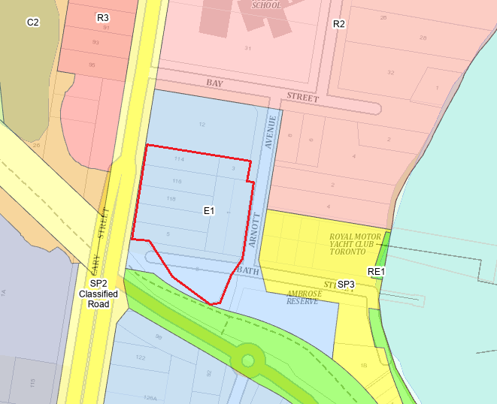
Figure 9 - Current zoning
According to the definitions in Clause 4 (contained in the Dictionary), the proposal satisfies the definition of commercial premises and residential flat buildings which is a permissible use with consent in the Land Use Table in Clause 2.3.
The zone objectives include the following (pursuant to the Land Use Table in Clause 2.3):
- To provide a range of retail, business and community uses that serve the needs of people who live in, work in or visit the area.
- To encourage investment in local commercial development that generates employment opportunities and economic growth.
- To enable residential development that contributes to a vibrant and active local centre and is consistent with the Council’s strategic planning for residential development in the area.
- To encourage business, retail, community and other non-residential land uses on the ground floor of buildings.
- To encourage employment opportunities in accessible locations.
The proposal is considered to be consistent with these zone objectives for the following reasons:
- The development provides the opportunity for a large commercial ground floor space with presentation to the main site frontage of Cary Street.
- The commercial space is currently open plan with the ability to be adapted to suit a variety of tenants.
- A large-scale residential development is included with residential use dominating both of the proposed towers.
General Controls and Development Standards (Part 2, 4, 5 and 7)
The LEP also contains controls relating to development standards, miscellaneous provisions and local provisions. The controls relevant to the proposal are considered in Table 4 below. The proposal does not comply with the development standard/s in Part 4 of the LEP and accordingly, a Clause 4.6 request has been provided with the application for the exceedance of the maximum height of buildings control.
Table 4: Consideration of the LEP Controls
Control | Requirement | Proposal | Comply
Height of buildings  (Cl 4.3(2)) | The development includes three separate building height limits  10m  13m  16m | The height of development within the respective height controls is:  16.84m  20.34m  20.14m | No
Acid sulphate soils  (Cl 7.1) | Will not disturb, expose or drain acid sulfate sols and cause environmental damage | An Acid Sulfate Soils Assessment and associated management plan has been provided and is considered satisfactory for the development. | Yes
Earthworks (Cl 7.2) | Will not have a detrimental impact on environmental functions and processes, neighbouring uses, cultural or heritage items or features of the surrounding land | Subclause (3)(g) has not been satisfied through detailed consideration of impact on ground water catchment and impact to the environmentally sensitive Toronto wetland. | No
Residential Development in certain employment and mixed use zones (7.10) | Residential development must include mixed use development in which most of the ground floor facing the primary street has an active frontage, for commercial purposes | The development includes a 928m² ground floor commercial space for the entire frontage to Cary Street. Cary Street is considered the main frontage for the development site. | Yes
Essential services (7.21) | Supply of water, electricity, management of sewage, stormwater drainage, vehicle access | All essential services are available to the development, with endorsement of the relevant authorities being provided. | Yes

The proposal is considered to be generally inconsistent with the LEP, particularly with regard to building height and unresolved impacts of earthworks.
Clause 4.6 Exceptions to development standards

A written request for exception to development standard Clause 4.3 Height of Buildings was included as part of the application.
There are three different building heights applicable to the development site as show in Figure 10 below. The development standards are 10m, 13m and 16m, with respective building heights of 16.84m 20.34m and 20.14m proposed within in each. This presents a maximum variation of 68.4%
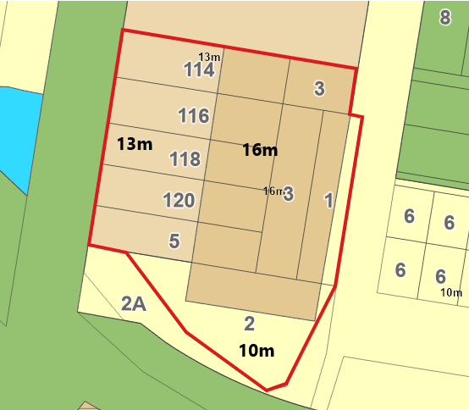
Figure 10 - Height of buildings map
The applicant has presented the following arguments for the variations proposed:
- The building envelope proposed has been considered in response to the site context and the height exceedance achieves a superior urban design outcome a positive response to the streetscape.
- There is an existing example of similar scale development with variation to the building height standard at 18 Warhust Avenue Toronto. This building is located at the southern end of the town centre and would appear as corresponding “bookend” developments.
- The proposal minimises impact on nearby heritage items by proposing the highest points of the development towards Cary street away from the items.
- The largest variation, to the 10m height limit, at the Arnott Avenue end relates only to a balcony projection on the southernmost portion of the building and would not be perceptible to general passers-by.
- There is an absence of significant material impact on the amenity of the environmental values of the locality.
- The proposal meets the zone objectives
- The proposal meets the objects of the EPA Act.
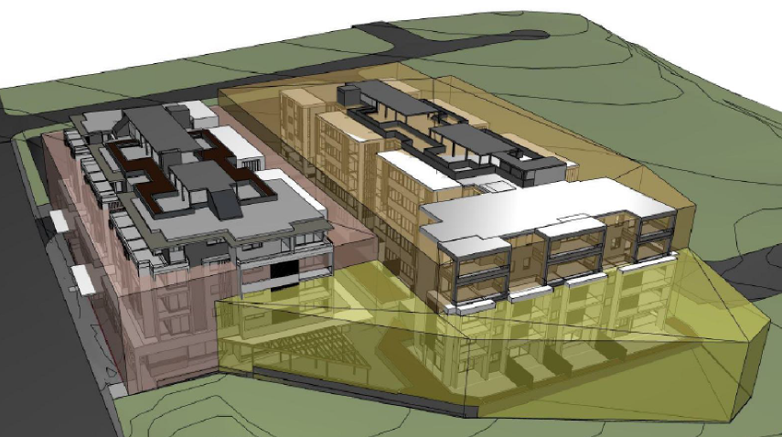
Figure 11 - Proposed height exceedances
Clause 4.6(4) of the LEP establishes preconditions that must be satisfied before a consent authority can exercise the power to grant development consent for development that contravenes a development standard. Clause 4.6(2) provides this permissive power to grant development consent for a development that contravenes the development standard is subject to conditions.
The two preconditions include:
- Tests to be satisfied pursuant to Cl 4.6(4)(a) – this includes matters under Cl 4.6(3)(a) and (b) in relation to whether the proposal is unreasonable and unnecessary in the circumstances of the case and whether there are sufficient environmental planning grounds to justify contravening the development standard and whether the proposal is in the public interest (Cl 4.6(a)(ii)); and
- Tests to be satisfied pursuant to Cl 4.6(b) – concurrence of the Planning Secretary.
In review of the Clause 4.6 exception provided to support the application, it was concluded the development standard is not unreasonable or unnecessary in the circumstances of the case.
The application has not demonstrated sufficient environmental planning grounds to justify contravening the development standard. Justification was generally limited the environmental impact to immediately adjoining land users, which is limited due the location of the development site.
The proposal would be substantially larger than envisaged adjoining development in an area which is in the process of beginning transition of redevelopment to increased scale. The proposal would set an undesirable precedent for excessively high and bulky buildings in the Toronto Town Centre and undermine the specific building height controls and objectives contained in LMLEP 2014 and LMDCP 2014.
The proposed development is not in the public interest as it is not consistent with the objectives of the standard.
Pursuant to this Council does not support the development application in it’s current form and is not satisfied that precondition 4.6(4)(a) can be met to proceed with the variation requested.
- Section 4.15 (1)(a)(ii) - Provisions of any Proposed Instruments
There are no draft or proposed instruments which have been the subject of public consultation under the EP&A Act, which are relevant to the proposal.
- Section 4.15(1)(a)(iii) - Provisions of any Development Control Plan
The following Development Control Plan is relevant to this application:
- Lake Macquarie Development Control Plan 2014 (LMDCP)
  - Part 4 Development in Business Zones
  - Part 9.13: Residential Flat Buildings
  - Part 10.4 Area Plans -Toronto Town Centre
The following items from the LMDCP have been raised for areas which require further consideration to demonstrate compliance:
Part 4 – Section 2.2 Scenic Values, Section 3.4 Streetscape Improvements, Section 7.2 Street trees and Streetscape Improvements and Section 7.3 Landscape and Tree Planting in Front Setback Areas.
The development had not appropriately considered requirements of the Toronto Streetscape Masterplan for all street frontages. The following landscape amendments were requested:
- Provide additional street tree planting, consistent with previous schemes, within Arnott Avenue and banded footpath to the frontage as per the Toronto Streetscape Masterplan and Landscape Design Guidelines.
- Indian hawthorn is considered a weed in NSW and shall be substituted out of the design. Suitable alternative planting is to be identified, the Lake Macquarie Backyard Habitat Planting Guide can provide information regarding alternate species.
- Investigate opportunities to connect the commercial space to the adjacent Toronto Foreshore Masterplan upgrade.
- A third Phoenix canariensis to the Cary Street frontage shall be included to strengthen the entry into Toronto.
- Tree guards are required for street tree’s along Arnott Avenue and Cary St. Refer to LMCC Standard Details Tree Guards and Toronto Streetscape Masterplan.
- Arnott Avenue: Geometry of the road and verge turf in the landscape plan is not consistent with Civil Engineers Drawings, in addition a turf species is to be specified from the approved turf species as per Landscape Design Guidelines.
- The Visual Impact Assessment is to be updated to accurately reflect proposed plantings.
No response to the request has been received.

Part 4 – Section 2.3 Geotechnical
The site and associated 20m buffer to the site contain the following geotechnical risk zone(s): Geo 3 & Geo 5.
Based on the scale of the development the applicable geotechnical zone is based on the most severe zone on the site and within a 20 m buffer to the site, therefore the Geo 3 zone is applicable.
A report by Chameleon Geosciences Ref: GS8030-1A. Rev:3 dated 25/02/2022 has been submitted and appears generally satisfactory.
There is a discrepancy between the type of sheet pile wall identified, with the Groundwater Assessment assuming water-tight secant pile walls and the report by Chameleon recommending contiguous pile walls which allow groundwater inflow into the excavation.
This discrepancy has not been addressed addressed.
Part 4 – Section 2.8 Stormwater Management
The design calculations for the upstream catchment flows to sag pit on Arnott Avenue shall be provided. The plans identify that the overland flow path is to be sized to convey 50% of the 1% AEP storm event. This is not consistent with the Lake Macquarie Water Cycle Management Guidelines.
The design should be the inlet capacity of the sag pit is reduced by 50% as a blockage factor, and the overland flow channel is required to convey 100% of the overflow from the sag pit in the 1% AEP storm event. If the pit and pipe are unable to have the capacity to capture and convey the 1% AEP storm event, then this distinction would matter. Th
This matter has not been addressed
Part 4 – Section 2.18 Social Impact
The development requires a Social Impact Assessment under the control to address potential social impacts. Social impacts have been partially identified within the in the Statement of Environmental Effects, however the following matters require further considerations:
- Community objection/concerns which have been raised through submissions shall be addressed.
- The extent to which the interests of the community as a whole are enhanced or sustained.
- The services and facilities that will be available to the residents (either within the development, or the local area), and how these will meet their needs.
- What measures have been included in the proposal, or are planned, in order to:
  - Encourage social interaction between the residents, as well as with the wider community
  - Enhance any positive social impacts
  - Mitigate or avoid any negative impacts
The above information has been requested and no response has been provided.
Part 4 – Section 6.14 Floor to Ceiling Heights
The development control requires a commercial ground floor ceiling height of 3.3m the development proposes a 2.7m ceiling height which would limit the potential land uses able to occupy the space. This has been raised through comments provided to the applicant and no response has been received.
Part 4 – Section 6.19 Solar Access and Orientation
The application is substantially below the minimum solar access requirements of 50% of the identified private opens spaces and 50% of all habitable rooms receiving 3 hours of solar access on June 21.
Additional consideration of Solar access has been provided in accordance with ADG requirements which were not met by the proposal. This information had been requested in this regard, no response has been received.
Part 4 – Section 6.25 Safety and Security
Based on the high levels of personal and property crime in the locality, and the scale and nature of the proposed development, an updated full crime risk assessment is required for the application. This information had been requested in this regard, no response has been received.
Part 4 – Section 8.2 Operational Waste Management
If bin cupboards on each floor are managed by caretakers at the property, Operational Waste Management Plan is required to be updated to reflect this. The top floor bin cupboard will require smaller bins and decanted to the basement bins, or mobile garbage bins placed in the outdoor space. This information had been requested in this regard, no response has been received.
Part 9.13 – Section 13.1 – Site requirements
The development site exceeds Council’s requirements for provision of a residential flat building which is supported.
Part 9.13 – Section 13.6 Landscape area
The development has a total landscape area of approximately 19% however this includes planting on structures and areas below the minimum width of 3m to be considered contributory.
While the minimum deep soil requirements of the ADG have been met through the design the proposal is considered deficient to the local controls for landscape area.
Part 10.4 – Section 2.1 Block Controls
The development site is located within Block F which demonstrates two separate towers with a maximum built form of three storeys for the western tower and four storeys for the eastern tower.
The general layout of tower location appears consistent with the block plan however the development proposes five storeys plus roof top terrace for both towers which is considered a significant variation to the block plan.
Part 10.4 – Section 3.3 Town Centre Heritage Area
The development application was provided with Statement of Heritage Impacts which identifies a schedule of colours and materials should be provided.
Heritage Interpretation is required as part of the application, general information regarding content and location of any interpretative elements should be provided with the application.
Development Contributions
The following contributions plans are relevant pursuant to Section 7.18 of the EP&A Act and have been considered in the recommended conditions (notwithstanding Contributions plans are not DCPs they are required to be considered):
- Lake Macquarie Development Contributions Plan – Toronto Contributions Catchment 2016
This Contributions Plan is applicable to the development application should the proposal be approved.
- Section 4.15(1)(a)(iiia) – Planning agreements under Section 7.4 of the EP&A Act
There have been no planning agreements entered into and there are no draft planning agreements being proposed for the site.
- Section 4.15(1)(a)(iv) - Provisions of Regulations
Section 61 of the 2021 EP&A Regulation contains matters that must be taken into consideration by a consent authority in determining a development application, with the following matters being relevant to the proposal:
These provisions of the 2021 EP&A Regulation have been considered and are not applicable to the development application.
  - Section 4.15(1)(b) - Likely Impacts of Development
The consideration of impacts on the natural and built environments includes the following:
- Context and setting – The proposal is not considered to be consistent with the context of the site nor is it consistent with the intended/desired future outcome with the proposal demonstrating significant variation to principle development standards.
- Access and traffic – The proposed development has not adequately demonstrated compliance with issues raised in relation to network capacity, with no response provided to demonstrate ability to provide upgrades.
- Public Domain – The development includes upgrade of the public domain, however this does not correspond to the requirements of the local streetscape masterplan, this could potentially have been managed through a condition of consent if fundamental items had been responded to.
- Utilities – all utilities available at the site. Vehicle access and stormwater management are the major deficiency identified for the development which remain outstanding.
- Heritage – The site is in vicinity to Environmental Heritage items listed in Schedule 5 Environmental heritage of the LMLEP and adjoins the Toronto heritage precinct identified by the LMDCP. Details of building finishes and heritage interpretation are required to satisfy the local requirements. This has not been provided.
- Water/air/soils impacts – The development is located at 4m AHD with two basement levels which will intersect the ground water table. This is a fundamental issue for the development proposal. Hydrogeological modelling provided has been reviewed by an external consultant which identified a number of omissions and errors on the information provided. An amended assessment would be required to demonstrate potential of the works to occur without concern of significant interruption to groundwater.
- Flora and fauna impacts – With unratified hydrogeological modelling provided, it is not possible to accurately determine what the impact to Toronto wetland would be. As such it is not satisfied the proposal would not have an adverse impact to offsite flora and fauna.
- Safety, security and crime prevention – A current crime risk assessment had been requested for the development to address current trends in the locality. This was not provided to support the development, and as such safety and security of the site has not been appropriately demonstrated.
- Social impact – A social impact assessment was requested to support the development particularly with licensed premises in the vicinity of the proposal. No information was provided in this regard to justify the social impact of the development.
- Cumulative impacts – The development presents a number of variations to EPI requirements, development standards and Council development controls. As such it could be concluded the cumulative impact of the development is in contrary to intent of the zoning and relevant EPI.
Accordingly, it is considered that the proposal will result in adverse impacts in the locality as outlined above.
  - Section 4.15(1)(c) - Suitability of the site
The development is not conducive to the locality. In particular the following site constraints have not been suitably addressed to demonstrate suitability
  - It has to been demonstrated how existing vehicle network can be updated to accommodate the development proposal.
  - Impacts to groundwater and corresponding impact to the Toronto wetlands.
  - Stormwater disposal and impact on Toronto wetlands
  - Section 4.15(1)(d) - Public Submissions
The development application was notified I accordance with Council Community Participation Plan which was relevant at the time of community consultation. A total of 97 public submissions were received which are considered in Section 5 of this report.
  - Section 4.15(1)(e) - Public interest
The proposed development is not consistent with the values of the local community, having regard to the significant number of submissions in the form of objections to the proposal. A total of 98 submissions were received by Council following notification of the proposed development – 67 objecting and 31 in support of the proposal.
The issues of concern raised in public submissions remain unresolved.
The development proposes variation to the building height development standard of the LMLEP without demonstrating compliance with the objectives to provide building heights appropriate for their locations and permit high quality urban forms.
The proposal will set an undesirable precedent for excessively high and bulky buildings in the Toronto Town Centre and undermine the urban form objectives and controls in Part 10.4 of Lake Macquarie Development Control Plan.
- REFERRALS AND SUBMISSIONS
  - Agency Referrals and Concurrence
The development application has been referred to various agencies for comment and referral as required by the EP&A Act and outlined below in Table 5.
The outstanding issues raised by Agencies are considered in the Key Issues section of this report
Table 5: Concurrence and Referrals to agencies
Agency | Concurrence/  referral trigger | Comments  (Issue, resolution, conditions) | Resolved
Concurrence Requirements (s4.13 of EP&A Act) N/A
Referral/Consultation Agencies
Electricity supply authority | Section 2.48 – State Environmental Planning Policy (Transport and Infrastructure) 2021  Development near electrical infrastructure | The application was referred to Ausgrid who raised no objection to the development and recommended conditions regarding construction related matters. | Y
Transport for NSW | Section 2.121 – State Environmental Planning Policy (Transport and Infrastructure) 2021  Development that is deemed to be traffic generating development in Schedule 3. | The development was identified as traffic generating development being residential accommodation with more than 5 dwellings with site access to a classified road.  The application was referred to TfNSW who raised no objection to the development and recommended conditions of consent. | N
Design Review Panel | Cl 28(2)(a) – SEPP 65  Advice of the Design Review Panel (‘DRP’) | The advice of the DRP has been considered in the proposal and is further discussed in the SEPP 65 assessment and the Key Issues section of this report. | N
Water and Sewer supply Authority | Refer to Hunter Water Corporation | Response provided advising requirements relating to water servicing, sewer servicing and asset protection/relocation were in Development Requirements Letter to the proponent dated 11 January 2022 (HW Ref 2016-933).  Hunter water reference 2016-933 was request form the applicant but remains outstanding. | N
Integrated Development (S 4.46 of the EP&A Act)
RFS | S100B - Rural Fires Act 1997  bush fire safety of subdivision of land that could lawfully be used for residential or rural residential purposes or development of land for special fire protection purposes | A Bushfire Safety Authority was issued with GTAs by NSW RFS, dated 29 November 2022 (Ref: DA20220822010125). | Y
NSW Water | S89-91 – Water Management Act 2000  water use approval, water management work approval or activity approval under Part 3 of Chapter 3 | Water NSW issued GTAs, dated 6 October 2022 (Ref: IDAS1145580). | Y
Subsidence Advisory NSW | Section 22, an application for approval to alter or erect improvements, or to subdivide land, within a mine subsidence district is to be made in a form approved by the Chief Executive. | The application was submitted to Subsidence Advisory as integrated development. General Terms of Approval (GTAs) were issued by Subsidence Advisory NSW, dated 5 September 2022 (Ref: TBA22-03189). | Y

  - Council Officer Referrals

The development application has been referred to various Council officers for technical review as outlined Table 6.

Table 6: Consideration of Council Referrals
Officer | Comments | Resolved
Property | Council’s Principal Project Officer reviewed the application and provided recommendations for conditions regarding impacts to the adjoining Council owned land at 2A Bath Street. | Yes
Environmental management | Council’s officer has reviewed the Noise Impact Assessment and no further information is required with recommended conditions of consent being provided. | Yes
Waste | Council’s Waste Officer has reviewed the development and requested minor changes to the operational waste management plan, to clarify how bins on each level will be managed. | No
Traffic | Council’s Traffic Engineer reviewed the development and requested additional information in relation to the turning head at the end of Arnott Avenue and dimensions/ details of road reserve and shared path widths. | No
Public drainage | Council’s Asset Management team for public drainage have reviewed the application and no objection was raised. | Yes
Social impact | Council’s Social Impact Planner has reviewed the application and while there has been no fundamental objection, further information regarding social impact of the proposal has been requested. | No
Safety and security | Council’s Planner for Youth and Safer Communities has reviewed the application and requested a complete and updated crime risk assessment. | No
Accessibility | Council’s Planner for Ageing and Disability has reviewed the application and raises no objection subject to recommended conditions of consent. | Yes
Heritage | Council’s Heritage Planner has requested a schedule of colours and materials be provided along with details for heritage interpretations including general content, location and interpretive elements. | No
Streetscape | Council’s Development Planner – Landscape has requested a number of changes to demonstrate compliance with the Toronto streetscape master plan, and for the provision of accurate visual montages. | No
Engineering | Council’s Senior Development Engineer requested additional information in regard to, geotechnical outcomes, stormwater management and design of parking and service areas. | No
Development contributions | A response has been provided with initial calculation of applicable fees under section 7.11. | Yes

The outstanding issues raised by Council officers are considered in the Key Issues section of this report.
  - Community Consultation
The proposal was notified in accordance with Council’s Community Participation Plan from 26 July 2022 until 16 August 2022, a formal extension of one week was provided which extended the notification period until 23 August 2022.
Notification was issued by letter to land owners adjacent to development site and along both sides of Bay Street. In addition, notification was provided members of the public who had lodged a submission against previous application DA/419/2018 on the site.
Seventy submissions were received during the initial notification period.
Council identified that the Geotechnical report by Charmeleon Geosciences Pty Ltd was not publicly available on Council’s website during the initial notification period. As such at conclusion of the initial notification a renotification was issued. Renotification included notification to all those originally notified plus any submitters from the initial period.
Renotification was carried out from 24 August 2022 until 15 September 2022.
Twenty-seven submissions were received during renotification
The Council received a total of 97 submissions, comprising 66 objections and 31 submissions in favour of the proposal. The issues raised in these submissions are considered in Table 7

Table 7: Community Submissions (objections)
Issue | No of submissions | Council Comments
Traffic impacts  Submissions raised concern the development will adversely impact on traffic congestion in the area and has not incorporated suitable upgrades to accommodate the proposal.  Further questions were raised as to the adequacy of the Traffic Impact Assessment provided to support the development. | 51 | The development was reviewed by Transport for NSW as traffic generating development and by Council’s Traffic Engineers for impact on the local road networks.  A number of details were requested form the applicant 23 December 2022 to demonstrate upgrades of Bay Street and Arnott Avenue could be provided to cater for the development.  The applicant has advised that n response wil be provided.  Outcome: This issue has not been resolved. Concerns with ability of the local road network to provide upgrades to cater for the development have not been addressed.
Parking  The development proposes a substantial increase to people accessing the area which will generate parking conflicts with existing uses in the area. | 21 | The development requires the following parking spaces:  - 115.5 residential spaces  - 27 residential visitor spaces.  - 28 commercial spaces.  The development proposes:  - 140 residential spaces (including 12 accessible spaces)  - 28 residential visitor spaces  - 38 commercial spaces (including 3 accessible spaces)  Outcome: Parking proposed meets the demand generated by the development and complies with DCP requirements.
Pedestrian safety  The increased number of vehicle movements will pose an unacceptable risk to immediate area in particular the impact on students at Toronto Public School located on the northern side of Bay Street. | 7 | Upgraded streetscape network was proposed for the frontage of the development to improve pedestrian connectivity.  Amendments to the design were requested to comply with the Toronto Streetscape masterplan.  Outcome: No response was provided to the request for changes, the issue remains unresolved.
Over development  The development is inconsistent with the established character and community expectation for development.  The development as proposed will take away from Toronto’s natural charm.  Development should be lower scale with no commercial elements. | 23 | The development as proposed is inconsistent with relevant state EPI’s, local development standards and development controls. It is concurred this would point to a level of over development.  A request to address design impacts of the proposal was issued to the applicant.  Consideration of local charm is not a matter for consideration.  Due to E1 zoning a commercial element to the main street frontage is required for any future residential development on the site. The scale of development should be guided by the relevant standard and development control plan.  Outcome: No response has been received to requested design changes.
Building design  The bulk and scale presented is not consistent with relevant development controls. |  | A number of changes were request in response to bulk and scale presented by the development in response to expert advice provided by the DRP.  Outcome: No response has been received to requested design changes.
Building height  Development exceeds the maximum building height standards and shouldn’t be supported.  The clause 4.6 variation provided is insufficient to justify the variation. | 12 | The development presents a significant departure from the relevant development standards for building height applicable to the site.  It is concurred the applicant has not provided adequate justification for the proposed height exceedance to meet the preconditions of Clause 4.6 (4).  Outcome: Additional information would be required or response to design outcomes recommended, currently the Clause 4.6 is not supported.
Essential Services  The development would require upgrade of essential services to cater for the proposal and this should not be carried by Council and the rate payers. | 5 | Any upgrade of essential infrastructure to service the development would be the responsibility of the developer.  Where the development required upgrade of service that had not been demonstrated this had been requested of the applicant.  Outcome: No response has been received to requested additional infrastructure upgrades.
Amenity  Amenity impacts to solar access, visual privacy and acoustic privacy. | 7 | Amenity impacts on adjoining land users were considered generally acceptable for the proposal. The development adjoins commercial development to the north and east with significant separation to development to south and west.  Outcome: Amenity impacts form the proposal were considered appropriate.
Toronto Wetlands and ground water impacts  Impacts on SEPP 14 Wetland have not been adequately addressed.  Considerations provided do not include wetland monitoring and place no importance on mature trees.  Appropriate consideration and assessment has not been provided against the Resilience and Hazard SEPP, Chapter 2 Coastal Management  Construction of two basement levels will have an adverse impact, intercepting natural ground water flows | 11 | The development was lodged under the provisions of RH SEPP which have been considered in detail above in this assessment report.  There are a number of fundamental area where compliance has not been demonstrated for development in proximity to Coastal Wetland and Coastal environment area.  Outcome: The consent authority is unable to approve the application without additional information to satisfy these requirements.
Flora and Fauna impacts  There will be a significant impact to the Toronto wetland as a result of impacts to the groundwater. | 11 | The potential impact to groundwater has not been appropriately addressed by the applicant. As no conclusive outcome has been demonstrated for groundwater Council is unable to determine the potential impact on the Toronto wetland.  Outcome: Groundwater information as noted above is to be clearly addressed to determine flora and fauna impacts of the proposal.
Stormwater and flooding impacts  Stormwater changes will have an impact on Toronto Wetlands.  Potential for flooding of basement levels as detailed in Northrop report. | 4 | The stormwater management plan provided has not demonstrated compliance with requirements of the LMDCP.  Outcome: An amended stormwater management plan would be required to demonstrate compliance.
Social and Affordable housing  No social housing has been included as part of the development.  Units provided within the development will not be “affordable”. | 2 | The development is private land and the developer has not applied to include social or affordable housing as part of the proposal.  There is no requirement for the site to include any social or affordable housing.  Outcome: This is not a matter for consideration under the current application. The developer is not required to provide social or affordable housing within the development.
Open Space and acquisition  The site should become open space for the community.  Council should purchase the site.  The development takes away form open space. | 8 | The development is privately owned land which is not identified for acquisition. Council is not in a position to acquire site nor is it able to require the applicant to provide the site as a public recreation area.  Outcome: This is not a matter for consideration under the current application. No further consideration is required in this regard.

Table 8: Community Submissions (support)
Issue | No of submissions | Council Comments
Housing diversity  The development provides a range of housing opportunities in an accessible location.  Provides an opportunity to downsize and stay local. | 19 | The development has a number of benefits which would support a range of new accommodation options within the immediate Toronto town centre area.
Economic benefit  The proposal is a great economic boost for western Lake Macquarie. The development will provide an overall economic boost and help to rejuvenate the local area. | 17 | The development would provide a range of economic benefits to the locality including activating the Cary Street frontage and providing opportunity for new commercial space within Toronto.  There would be a direct benefit to the economy through construction of the development.
Commercial Space  The commercial space is well thought out and will promote pedestrian traffic in the area. | 17 | The commercial spaces would have activated the Cary Street frontage. This could create confidence in the local area to promote further development opportunities.
Design changes  The application has included changes form the previous proposal to address prior issues | 3 | While a number of changes from the previous application DA/419/2018 had been made the development retains a number of noncompliance with EPI’s development standards and development controls.
- KEY ISSUES
The following key issues are relevant to the assessment of this application having considered the relevant planning controls and the proposal in detail:
  - Urban Design
The proposed development and supporting architectural plans are contrary to the provisions of SEPP65 and the ADG. In its current form the development will result in poor residential amenity to the future occupants of the site. The following areas of noncompliance were identified:
- The proposed development does not provide adequate separation distances between upper levels as required by Part 2F Building Separation of the ADG.
- The development presents poor relationship with the public reserve to the south and therefore does not satisfy 3C Public domain interface.
- The proposed development does not provide the minimum 70% of units with a minimum 3 hours of direct solar access between 9am and 3pm at mid-winter. Current design provides only 42 units or 39% with the minimum 3-hour requirement for the Lake Macquarie Area.
- Commercial premises provided at ground level is provided with a 2.7m ceiling height which does not comply with the minimum 3.3m requirement of 4C Ceiling heights of the ADG.
- Studio apartments do not meet the minimum 35m² internal area requirement prescribed by section 4D Apartment size and layout of the ADG.
  - Building bulk
The proposed building height and bulk and scale of the development will result in an unacceptable, overwhelming visual impact when viewed from Cary Street, Arnott Avenue and Lake Macquarie. The proposal is inconsistent with all relative DCP design controls and applicable development standards as outlined below:
- The proposed building height of 20.3 metres is contrary to the statutory height control of 13 metres to Cary Street contained within clause 4.3 of LMLEP 2014.
- The proposed building height and bulk and scale is contrary to Section 6.12 (Building height) of LMDCP 2014 specifically objective (c) “to ensure that the building height does not overwhelm the public street and is compatible with the scale of surrounding development”.
- The proposed building height and bulk and scale is contrary to Part 10.4 (Toronto Town Centre Area Plan) of LMDCP 2014 specifically:
- Section 1.4 (Desired future character) which seeks to maintain the visual prominence of the Toronto Hotel from the water and the lake foreshore and ensure development should be appropriate height and scale to avoid undesirable impacts on the scenic quality of the township.
- Section 2.1 (Block controls) specifically objective (c) which seeks “to ensure that building scale, height and setback contributes to the desired future character of the town centre”. Nowhere in the Toronto Town Centre are buildings over four storeys.
- Section 6.2 (Building height) requiring visual bulk in the Town Centre to be minimised to maintain the visual prominence of the Toronto Hotel.
- Section 6.4 (Building exteriors). requiring buildings visible from the foreshore of the lake to be predominantly finished in muted tones and muted colours, restricting white and brightly coloured finishes.
- The proposed building height and bulk and scale of the development is contrary to clause 2 (Aims, objectives of Policy) of SEPP 65 (Design Quality of Residential Apartment Development) specifically 3(b) “to achieve better built form and aesthetics of buildings and of the streetscapes and the public spaces they define” and 3(d) “to maximise amenity, safety and security for the benefit of its occupants and the wider community”.
  - Clause 4.6 (Exceptions to development standards)
The submitted clause 4.6 (Exceptions to development standards) request of Lake Macquarie Local Environmental Plan 2014 (LMLEP 2014) to vary Clause 4.3 (Height of buildings) of LMLEP 2014 is considered inadequate for the following reasons:
- The submitted clause 4.6 (Exceptions to development standards) request of LMLEP 2014 has not demonstrated that compliance with the development standard is unreasonable or unnecessary in the circumstances of the case.
- The submitted clause 4.6 (Exceptions to development standards) request of LMLEP 2014 has not demonstrated that there are sufficient environmental planning grounds to justify contravening the development standard.
- The proposed development is not in the public interest as it is not consistent with the objectives of the standard.
- The proposal will set an undesirable precedent for excessively high and bulky buildings in the Toronto Town Centre and undermine the specific building height controls and objectives contained in LMLEP 2014 and LMDCP 2014.
  - Traffic, vehicle access and pedestrian movements
The proposed development has not adequately addressed the traffic vehicle access impacts of the development to the surrounding streets, or pedestrian movements. The following areas of noncompliance have been identified:
- The proposal is contrary to the objectives of clause 2.119 (Development with frontage to classified road) of T&I SEPP namely (a) which requires “that new development does not compromise the effective and ongoing operation and function of classified roads”.
- The applicant has not provided the additional information, or addressed the concerns raised, by Transport for New South Wales (TfNSW) dated 29 August 2022 in response to section 2.122 Traffic generating development of T&I SEPP.
- The proposal does not adequately address the narrow width of Arnott Avenue adjoining the site, the implications of this for the safe movement of vehicles, cycles and pedestrians, and requirements for road widening and turning manoeuvres.
- Internal service vehicle movements for medium rigid vehicles have not demonstrated adequate grade transitions in accordance with requirements of Australian Standard AS2890.2.
- The proposed development does not provide adequate detail in regard to pedestrian movements and footpath requirements for the development.
- The proposed development is contrary to Part 10.4 (Toronto Town Centre Area Plan) of LMDCP 2014 specifically Section 1.4 (Desired future character) which seeks to improve pedestrian connections throughout the Town Centre.

  - Landscape and visual impact
An accurate visual impact assessment has not been provided to reflect proposed plantings and give an accurate montage of the proposal for assessment. Nor have the requirements of the Toronto Streetscape Masterplan been addressed for all street frontages. The following noncompliance have been identified:
- Landscape plans demonstrate two Araucaria species trees along Arnott Avenue is a reduction from an earlier scheme and not sufficient. Additionally, above ground power lines exist in this immediate locality. View 6 North east perspective of the architectural plans (relied upon in Visual Impact Assessment) incorrectly shows four trees and no overhead electricity wires.
- A reduction in planting to Cary Street from previous iterations is not supported. Additional Phoenix canariensis is required to strengthen the entry into Toronto.
- Landscape design and perspectives do not give due regard to existing overhead powerlines and potential conflicts this could have with species proposed.
- Overall inconsistency with Toronto Streetscape Masterplan and landscape design guidelines.
  - Safety and Security
An out-dated crime risk assessment has been provided to support the development application. Local crime statistics identify several matters that require consideration and design solutions. The following items have been raised for concern:
- Non-domestic intimidation, stalking, harassment and assault, malicious damage to property, break and enter and motor vehicle theft were all identified as impacting the Toronto Area.
No consideration of Crime Prevention Through Environmental Design (CPTED) has been provided to demonstrate how the development has been designed to deter the above activities.
- Interface of the development to the public reserve at the south provides a climbable structure accessible from the public domain.
- Location of the commercial lift requires commercial staff and customer to traverse the ground level courtyard which fronts residential units. Clear separation of these uses would benefit safety of residents.
  - SEPP Resilience and Hazards 2021
The development site is partially affected by the Coastal Wetland buffer and is wholly within the mapped coast environmental area and coastal use area requiring consideration under Chapter 2 Coastal management of SEPP Resilience and Hazards 2021. The current supporting information provided by CMW Geoscience and AGEC has been considered and has not clearly addressed there would be not adverse impact to ground and surface water process to satisfy Chapter 2. The following areas have been identified:
- Insufficient information has been received to demonstrate there would be no significant impact from stormwater runoff.
- Insufficient information has been received to determine there would be no adverse impact to groundwater as a result of earthworks proposed.
- Council is not satisfied there would be not be significant impact on adjacent Toronto wetland.
- The proposed development is contrary to the objectives and controls contained within Section 2.8 (Stormwater Management) of LMDCP.
  - Essential Infrastructure
The proposed development has not made adequate provision for essential services including stormwater, suitable vehicular access and relocation of the Hunter Water main. This fails to satisfy the requirements of:
- Clause 7.21 Essential services of LMLEP
- Section 2.8 Stormwater management of LMDCP
- Section 2.21 (Utility Infrastructure) of LMDCP
- Section 5.1 Traffic and vehicle access of the LMDCP
- Section 5.2 Design of parking and service areas of the LMDCP
- The impacts of the proposed infrastructure, and any additional required infrastructure proposed, have not been adequately addressed.
  - Waste management
Further detail is required for ongoing waste management to demonstrate management for the development
  - Heritage conservation
The development application was provided with a supporting Statement of Heritage Impact which requires the following additional information for heritage conservation outcomes to be considered satisfactory:
- Recommendations of the SHI recommend inclusion of further colours into the proposal. A detailed schedule of finishes is to be provided for consideration.
- Heritage interpretation is required. General information regarding content and location of any interpretative elements is to be provided.
  - Sheet pile wall type
Insufficient detail has been provided to confirm the final type of sheet pile wall required which could impact the overall groundwater consideration of the development.
Geotechnical report by Chameleon Geosciences provides assessment assuming water-tight secant pile walls.
Groundwater Drawdown Model and Detailed Settlement Analysis by CMW Geosciences recommends contiguous pile walls which allow groundwater inflow.
The inconsistency is required to be addressed.
- CONCLUSION

This development application has been considered in accordance with the requirements of the EPA Act and the Regulations as outlined in this report. Following a thorough assessment of the relevant planning controls, issues raised in submissions and the key issues identified in this report, it is considered that the application cannot be supported.
While there are a number of positive elements to the development proposal, the applicant’s decision to not provide any response to RFI has left the proposal in a form that can be supported for approval.
The development has failed to demonstrate compliance with relevant State EPI’s, local development standards and development controls. Adequate justification for variation proposed has not been provided to enable support of the development applciaiotn.
It is considered that the key issues as outlined in Section 5 have not been resolved. satisfactorily through amendments to the proposal and/or in the recommended draft conditions at Attachment A.

- RECOMMENDATION

That the Development Application DA/1651/2022 for mixed use development comprising commercial premises and residential flat building at;
- 114, 116, 118 and 120 Cary Street Toronto;
- 1, 2, 3 and 5 Bath Street Toronto; and
- 3 Arnott Avenue Toronto.
be refused pursuant to Section 4.16(1)(a) or (b) of the Environmental Planning and Assessment Act 1979 subject to the draft reasons for refusal attached to this report at Attachment A.
The following attachments are provided:

- Attachment A: Draft reasons for refusal
- Attachment B: SEPP 65 Urban Design Review Panel Recommendations
- Attachment C: Plan and document schedule

